Lead Manager Workflow – Chronological Process:

Parties involved
Lead qualification Admin
Lead Manager
Director of CRM
ISA
Agents
Office administrator
CRM Coach
Broker

Daily Operations Workflow

Step 1 – Review Lead Manager Email Inbox
The Lead Manager begins the day by reviewing all incoming emails from Real Geeks and internal team communications.
Primary objectives:
- Review lead notifications.
- Identify showing requests submitted by prospects.
- Monitor lead status changes.
- Review requests from agents and team members.
- Identify actions that require immediate attention.
Dailly Task
Activity | Time(min) | Avg work volume | Tool | Parties involved
Review Lead manager Email inbox | 70 | 100 | Gmail, Real geeks | Lead Manager

Step 2 – Review CRM Tasks and Follow-Up Requests
The Lead Manager accesses Real Geeks to review all open tasks and follow-up requests generated by team members.
Activities include:
- Reviewing calls, texts, and emails logged by agents.
- Verifying that each activity contains proper notes.
- Identifying missing documentation.
- Sending correction requests through Real Geeks when information is incomplete.
- Updating task status after the review is completed.

Dailly Task
Activity | Time(min) | Avg work volume | Tool | Parties involved
Review Real Geeks Tasks and Team Activity | 60 | 10–25 | Real geeks | Lead Manager, agent

Step 3 – Review Newly Generated Website Leads
The Lead Manager reviews new website-generated leads that have already been screened and qualified by Daniel Alvarez.
Activities include:
- Verifying contact information.
- Reviewing lead source information.
- Confirming the lead is ready for assignment and tracking.
Dailly Task
Activity | Time(min) | Avg work volume | Tool | Parties involved
Review Newly Generated Website Leads | 30 | 5 | Real geeks | Lead Manager, ISA Lead qualification Admin

Step 4 – Enter Lead Information into the Tracking Spreadsheet
Once verified, lead information is manually entered into the Google Sheets tracking report.
Information recorded:
- Date generated.
- Time generated.
- Lead source.
- Marketing channel.
- Contact information.
- Summary of actions taken.
Only qualified leads previously reviewed by Daniel Alvarez are added to the tracker.

Dailly Task
Activity | Time(min) | Avg work volume | Tool | Parties involved
Enter Lead Information into the Tracking Spreadsheet | 30 | 1 | Google sheets | Lead Manager

Step 5 – Coordinate Lead Assignment
Agent leads admin reviews qualified leads and presents them to the Lead Management group for assignment.
Assignment decisions are based on:
- Property location.
- Agent territory coverage.
- Agent availability.
After agreement is reached, the lead is assigned within Real Geeks.

Dailly Task
Activity | Time(min) | Avg work volume | Tool | Parties involved
Lead Assignment Process | 10 | 1 | Whatsapp, Realgeeks | Lead Manager, Lead qualification Admin, Coach

Step 6 – Monitor Agent Follow-Up Compliance
After assignment, the Lead Manager verifies that agents have contacted the assigned lead according to company standards.
Activities include:
- Reviewing follow-up activities.
- Confirming calls were completed.
- Verifying CRM notes were entered.
- Sending reminders when follow-up is missing.
- Reporting recurring non-compliance issues.
Agents who fail to comply may temporarily lose eligibility to receive new leads.
Dailly Task
Activity | Time(min) | Avg work volume | Tool | Parties involved
Agent Follow-Up Compliance Review | 75 | 5 | Whatsapp, Realgeeks | Lead Manager

Step 7 – Review Walk-In and Call-In Leads
The Lead Manager reviews walk-in and call-in lead information submitted by office staff and agents.
Activities include:
- Verifying lead information entered into Real Geeks.
- Requesting missing contact information.
- Contacting agents for clarification when needed.
- Calling prospects regarding showing activity.
- Coordinating lead reassignment when required.
Dailly Task
Activity | Time(min) | Avg work volume | Tool | Parties involved
Walk-In and Call-In Lead Audits | 15 | 3 | Real geeks , Email , Phone | Lead Manager , Office Administrator, management team

Step 8 – Perform Quality Assurance Lead Audits
The Lead Manager conducts quality assurance reviews of walk-in and call-in leads.
Activities include:
- Reviewing CRM notes entered by agents.
- Contacting selected leads to verify service quality.
- Confirming agent interactions occurred as documented.
- Recording audit findings.
Audit Requirements:
- Review a minimum of two leads per agent.
- Audit approximately 25–30% of all walk-in and call-in leads.
Dailly Task
Activity | Time(min) | Avg work volume | Tool | Parties involved
Perform Quality Assurance Lead Audits | 3 | 1 | Real geeks, phone | Lead Manager

Step 9 – Document Audit Results
Audit findings are entered into Google Sheets for performance tracking and reporting purposes.
Activities include:
- Recording compliance results.
- Identifying performance trends.
- Escalating concerns to management when necessary.
Reports generated support:
- Daily reporting.
- Weekly reporting.
- Monthly reporting.
Dailly Task
Activity | Time(min) | Avg work volume | Tool | Parties involved
Document Audit Results | 5 | 5 | Google sheets | Lead Manager

Weekly Operations Workflow

Step 10 – Participate in Team Alignment Meetings
The Lead Manager participates in recurring meetings with:
- Daniel Alvarez.
- Dona Vickers.
- David.
Topics include:
- Lead management processes.
- CRM updates.
- Best practices.
- Performance improvement opportunities.
Weekly Task
Activity | Time(min) | Avg work volume | Tool | Parties involved
Team Alignment and Coaching Meetings | 60 | 1 | whatsapp | Lead Manager, ISA Lead qualification Admin, Coach

Step 11 – Conduct and Support Coaching Sessions
Based on audit findings and coaching requests, the Lead Manager provides performance feedback to agents.
Virtual Coaching:
- Approximately 2 sessions per week.
- Average duration: 30 minutes per session.
For in-person coaching sessions conducted by Dona Vickers:
- Review coaching notes.
- Document commitments and action plans.
- Send follow-up summaries to management.
Weekly Task
Activity | Time(min) | Avg work volume | Tool | Parties involved
Conduct and Support virtual Coaching Sessions | 60 | 2 | whatsapp, Email | Lead Manager, Coach
Conduct and Support in person Coaching Sessions | 120 | 6 | whatsapp, Email | Lead Manager, Coach

Step 12 – Update RGL Hand-Off Report
The Lead Manager updates lead tracking and conversion metrics by region.
Activities include:
- Reviewing lead volume.
- Updating conversion rates.
- Completing regional performance reports.
- Sending summary reports to Brock.
- Presenting results during weekly meetings.

Weekly Task
Activity | Time(min) | Avg work volume | Tool | Parties involved
Update RGL Hand-Off Report | 10 | 1 | Google sheets , Real geeks | Lead Manager , Coach

Step 13 – Attend Staffing and Operations Meetings
The Lead Manager participates in leadership and staffing meetings.
Meeting Schedule:
- Tuesday Team Meeting: 180 minutes.
- Thursday Team Meeting: 90 minutes.
- Weekly Staffing Meeting: 30–60 minutes.
Topics include:
- Lead distribution.
- Staffing requirements.
- Agent performance.
- Operational updates.
Weekly Task
Activity | Time(min) | Avg work volume | Tool | Parties involved
Weekly Staffing Meeting | 60 | 1 | whatsapp | Lead Manager, Lead qualification Admin, Coach, agents
Weekly meeting with every team member | 270 | 2 | whatsapp | Lead Manager, Lead qualification Admin, Coach, agents

Step 14 – Correct Missing or Untracked Leads
When leads are discovered that were not entered into Real Geeks, the Lead Manager performs a data correction process.
Activities include:
- Researching missing lead information.
- Creating lead records.
- Updating tracking reports.
- Following up on incomplete information.
Weekly Task
Activity | Time(min) | Avg work volume | Tool | Parties involved
Correct Missing or Untracked Leads | 20 | 2 | Google sheets , Real geeks | Lead manager, Coach

Monthly Operations Workflow

Step 15 – Review Training Materials and Develop Learning Resources
The Lead Manager reviews training content from Real Geeks University and identifies recurring agent performance issues.
Activities include:
- Reviewing training resources.
- Identifying common operational challenges.
- Creating targeted training packages and recommendations.
Monthly Task
Activity | Time(min) | Avg work volume | Tool | Parties involved
Review Training Materials and Develop Learning Resources | 30 | 1 | Real geeks , Email | Lead Manager

Task frequency daily, weekly and monthly workload:
Dailly Task
Activity | Time(min) | Avg work volume | Tool | Parties involved
Review Lead manager Email inbox | 70 | 100 | Gmail, Real geeks | Lead Manager
Review Real Geeks Tasks and Team Activity | 60 | 25 | Real geeks | Lead Manager, agent
Review Newly Generated Website Leads | 30 | 5 | Real geeks | Lead Manager, ISA Lead qualification Admin
Lead Assignment Process | 10 | 1 | Whatsapp, Realgeeks | Lead Manager, ISA Lead qualification Admin, Coach
Agent Follow-Up Compliance Review | 75 | 5 | Whatsapp, Realgeeks | Lead Manager
Walk-In and Call-In Lead Audits | 15 | 3 | Real geeks , Email , Phone | Lead Manager , Office Administrator, management team
Perform Quality Assurance Lead Audits | 3 | 1 | Real geeks, phone | Lead Manager
Document Audit Results | 5 | 5 | Google sheets | Lead Manager
Total min | 268
Total H | 4.466

Weekly Task
Activity | Time(min) | Avg work volume | Tool | Parties involved
Weekly Staffing Meeting | 60 | 1 | whatsapp | Lead Manager, Lead qualification Admin, Coach, agents
Update RGL Hand-Off Report | 10 | 1 | Google sheets , Real geeks | Lead Manager , Coach
Team Alignment Meetings | 60 | 1 | whatsapp | Lead Manager, Lead qualification Admin, Coach
Conduct and Support virtual Coaching Sessions | 60 | 2 | whatsapp, Email | Lead Manager, Coach
Conduct and Support in person Coaching Sessions | 120 | 6 | whatsapp, Email | Lead Manager, Coach
Weekly meeting with every team member | 270 | 2 | whatsapp | Lead Manager, Lead qualification Admin, Coach, agents
Correct Missing or Untracked Leads | 30 | 2 | Google sheets , Real geeks | Lead manager, Coach
Total min | 610
Total H | 2.033

Monthly Task
Activity | Time(min) | Avg work volume | Tool | Parties involved
Review Training Materials and Develop Learning Resources | 30 | 1 | Real geeks , Email | Lead Manager
Total min | 30
Total H | 0.5
Monthly task H divided per day | 0.016666667
Dailly Task worked H | 4.466666667
Weekly Task H divided per day | 2.033333333
Total Dailly worked H | 6.516666667
Available work time per day | 8

Average task frequency for daily , weekly and monthly duties combined during a regular week | Time(min
Agent Follow-Up Compliance Review | 75
Conduct and Support in person Coaching Sessions | 24
Conduct and Support virtual Coaching Sessions | 12
Correct Missing or Untracked Leads | 6
Document Audit Results | 5
Lead Assignment Process | 10
Perform Quality Assurance Lead Audits | 3
Review Lead manager Email inbox | 70
Review Newly Generated Website Leads | 30
Review Real Geeks Tasks and Team Activity | 60
Review Training Materials and Develop Learning Resources | 1
Team Alignment Meetings | 12
Update RGL Hand-Off Report | 2
Walk-In and Call-In Lead Audits | 15
Weekly meeting with every team member | 54
Weekly Staffing Meeting | 12
Enter Lead Information into the Tracking Spreadsheet | 30
Total time min | 421
Total time H | 7.01666

Overall conclusion:
Based on the activities observed, the Lead Manager role requires approximately 421 minutes (7.01 hours) of productive work per day, representing 87.7% of an 8-hour effective workday. While the position currently operates within capacity, the workload is heavily dependent on manual auditing, reporting, and compliance monitoring processes. Any increase in lead volume, coaching requirements, or audit activities could quickly push utilization above sustainable levels, reducing available time for strategic initiatives and operational improvements.

The three most significant bottlenecks are:
- Agent Follow-Up Compliance Reviews (75 min/day)
- Email Monitoring and Notification Management (70 min/day)
- CRM Task and Activity Audits (60 min/day)
Together, these activities consume 205 minutes per day, representing approximately 52% of the Lead Manager's total workload. Any increase in lead volume, agent headcount, or compliance issues would likely create capacity constraints and reduce the Lead Manager's ability to focus on coaching, process improvement, and strategic initiatives.
Recommendation:
Prioritize automation and process standardization for compliance monitoring, CRM auditing, and notification management, as these areas represent the greatest opportunity for workload reduction and operational efficiency gains.

Company Brand | STANDARD OPERATING PROCEDURE  Area: Lead Manager  Prepared: Documentation team  Reviewed: | SOP-1-01  6/2/2026  Version: 1.0  Pg: 1 -13

STANDARD OPERATING PROCEDURE:
Lead Manager duties and responsibilities guide.

Company Brand | STANDARD OPERATING PROCEDURE  Area: Lead Manager  Prepared: Documentation team  Reviewed: | SOP-1-01  6/2/2026  Version: 1.0  Pg: 2 -13
Index

1. Purpose 2
2. Scope 2
3. Definitions 3
4. Roles and Responsibilities 4
5. Procedure 5
6.Documented Information 9
6.1 References 9
6.2 Troubleshooting 10
6.3 Related SOPs 10
7 . Flowchart 11
8 . Version Control 12

1. Purpose
The purpose of this procedure is to establish a standardized process for lead monitoring, CRM auditing, lead assignment oversight, compliance verification, reporting, coaching support, and quality assurance activities performed by the Lead Manager.
The process ensures that all leads are properly tracked, assigned, documented, audited, and followed up according to company standards while maintaining data accuracy within Real Geeks CRM.

2. Scope
This SOP applies to all Marketing/Web Leads, Walk-In Leads, and Call-In Leads managed through Real Geeks CRM.
The procedure is performed:
- Daily for lead monitoring and compliance activities.
- Weekly for reporting, coaching, and staffing reviews.
- Monthly for training material review and process improvement activities.
- As needed for lead corrections, escalations, and special projects.
Company Brand | STANDARD OPERATING PROCEDURE  Area: Lead Manager  Prepared: Documentation team  Reviewed: | SOP-1-01  6/2/2026  Version: 1.0  Pg: 3 -13

3. Definitions
Lead Manager
Employee responsible for lead auditing, compliance monitoring, reporting, coaching support, and assignment oversight.
Real Geeks CRM
Primary customer relationship management platform used to manage leads and agent activities.
Marketing/Web Lead
Lead generated through company marketing campaigns or website forms.
Walk-In Lead
Lead generated through an office visit.
Call-In Lead
Lead generated through incoming office phone calls.
Lead Audit
Review process used to verify proper lead handling and documentation by agents.
QA Call
Quality Assurance call performed with a prospect to verify service quality and agent interaction.

Company Brand | STANDARD OPERATING PROCEDURE  Area: Lead Manager  Prepared: Documentation team  Reviewed: | SOP-1-01  6/2/2026  Version: 1.0  Pg: 4 -13

4. Roles and Responsibilities
Position | Responsible For
Lead Manager | Lead auditing, compliance reviews, reporting, coaching support, assignment oversight, QA calls
Lead qualification admin | Lead qualification, initial prospect contact, lead assignment coordination
Agents | Lead follow-up, communication with prospects, CRM documentation
Office Administrator | Submission of walk-in and call-in lead information
Coach | Coaching recommendations, CRM process guidance
CRM director | CRM optimization and process improvement
Brooker | Oversight, approvals, staffing reviews

Company Brand | STANDARD OPERATING PROCEDURE  Area: Lead Manager  Prepared: Documentation team  Reviewed: | SOP-1-01  6/2/2026  Version: 1.0  Pg: 5 -13

5. Procedure
Step 1 – Review Email Notifications
- Access the Lead Manager inbox.
- Review Real Geeks notifications.
- Identify lead activity updates and showing requests.
- Review agent and team communications.
- Determine required actions.
Expected Volume:
- Approximately 100 emails per day.

Step 2 – Review CRM Tasks and Follow-Up Requests
- Access Real Geeks CRM.
- Review open tasks and follow-up requests.
- Verify calls, texts, and emails are documented.
- Review notes entered by agents.
- Identify missing information.
- Send correction requests when necessary.
- Update task status after review.

Step 3 – Review New Website Leads
- Review newly generated leads.
- Verify lead information.
- Confirm lead qualification completed by Daniel Alvarez.
- Prepare leads for tracking and assignment.
Company Brand | STANDARD OPERATING PROCEDURE  Area: Lead Manager  Prepared: Documentation team  Reviewed: | SOP-1-01  6/2/2026  Version: 1.0  Pg: 6 -13

Step 4 – Update Lead Tracking Spreadsheet
- Open Google Sheets tracker.
- Enter lead generation date and time.
- Record lead source.
- Record marketing channel.
- Enter contact information.
- Document actions taken.

Step 5 – Coordinate Lead Assignment
- Review qualified leads.
- Verify property location.
- Verify agent territory coverage.
- Coordinate assignment discussions through WhatsApp.
- Confirm lead assignment within Real Geeks.

Step 6 – Monitor Agent Follow-Up Compliance
- Review assigned lead activity.
- Verify contact attempts were completed.
- Confirm CRM notes were entered.
- Send reminders when follow-up is missing.
- Document compliance issues.
- Escalate recurring issues when necessary.

Step 7 – Review Walk-In and Call-In Leads
- Review lead information entered by agents or office staff.
Company Brand | STANDARD OPERATING PROCEDURE  Area: Lead Manager  Prepared: Documentation team  Reviewed: | SOP-1-01  6/2/2026  Version: 1.0  Pg: 7 -13

- Verify contact information is complete.
- Request missing information when required.
- Contact agents via email or phone for clarification.
- Coordinate lead reassignment when necessary.
- Contact prospects regarding showing activity if needed.

Step 8 – Conduct Quality Assurance Audits
- Select leads for audit review.
- Review CRM notes.
- Contact prospects to verify interactions.
- Confirm service quality.
- Document audit findings.
- Identify coaching opportunities.
Audit Requirement:
- Minimum of two leads per agent.
- Approximately 25–30% of walk-in and call-in leads audited.

Step 9 – Record Audit Results
- Enter audit findings into Google Sheets.
- Update performance tracking records.
- Document compliance concerns.
- Escalate issues requiring management review.

Step 10 – Conduct Coaching Activities
- Review coaching recommendations.
Company Brand | STANDARD OPERATING PROCEDURE  Area: Lead Manager  Prepared: Documentation team  Reviewed: | SOP-1-01  6/2/2026  Version: 1.0  Pg: 8 -13

- Schedule coaching sessions.
- Provide performance feedback.
- Document commitments and action items.
- Share summaries with management.
For in-person coaching sessions:
- Review notes provided by the coach.
- Document commitments.
- Email summary to management.

Step 11 – Update Weekly Reports
- Update RGL Hand-Off Report.
- Review conversion metrics.
- Prepare summary for Broker.
- Present results during weekly meetings.

Step 12 – Participate in Meetings
Attend:
- Weekly staffing meetings.
- Team alignment meetings.
- CRM optimization meetings.
- Coaching discussions.
- Leadership meetings.

Step 13 – Review Training Materials
- Access Real Geeks University.
Company Brand | STANDARD OPERATING PROCEDURE  Area: Lead Manager  Prepared: Documentation team  Reviewed: | SOP-1-01  6/2/2026  Version: 1.0  Pg: 9 -13

- Review training materials.
- Identify recurring performance issues.
- Develop targeted learning recommendations.
Frequency:
- Monthly.

Step 14 – Correct Missing Lead Records
When lead records are missing:
- Research missing information.
- Create lead records in Real Geeks.
- Update reporting trackers.

6.Documented Information

6.1 References
Tools and platforms used
Real Geeks CRM
Gmail
Google Sheets Lead Tracker
RGL Hand-Off Report
Google Calendar
WhatsApp
Real Geeks University

Company Brand | STANDARD OPERATING PROCEDURE  Area: Lead Manager  Prepared: Documentation team  Reviewed: | SOP-1-01  6/2/2026  Version: 1.0  Pg: 10 -13

6.2 Troubleshooting
Issue | Action
Missing lead information | Contact agent, Office administrator, or prospect to obtain required information
Missing CRM notes | Request correction from responsible agent
Lead not contacted | Notify agent and document compliance issue
Incorrect lead assignment | Reassign lead based on territory and availability
Missing historical leads | Create lead records and update tracking reports
Walk-in or call-in lead not documented | Request information from agent and provide follow up until the lead is added to the system

6.3 Related SOPs

Company Brand | STANDARD OPERATING PROCEDURE  Area: Lead Manager  Prepared: Documentation team  Reviewed: | SOP-1-01  6/2/2026  Version: 1.0  Pg: 11 -13

7 . Flowchart
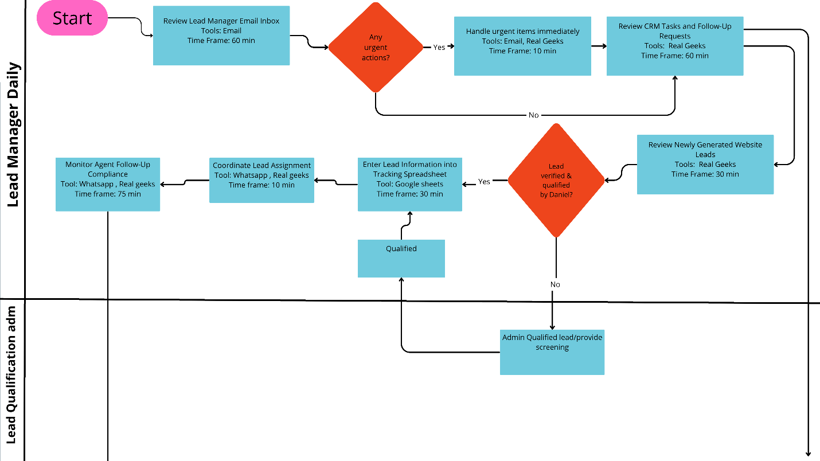
The following flowchart provides a consolidated overview of the Lead Manager's responsibilities and operational workflow. It reflects the average activities performed throughout a typical work week and includes daily, weekly, and monthly tasks combined into a single process map. The workflow illustrates key responsibilities, stakeholder interactions, decision points, and supporting systems involved in the lead management process.

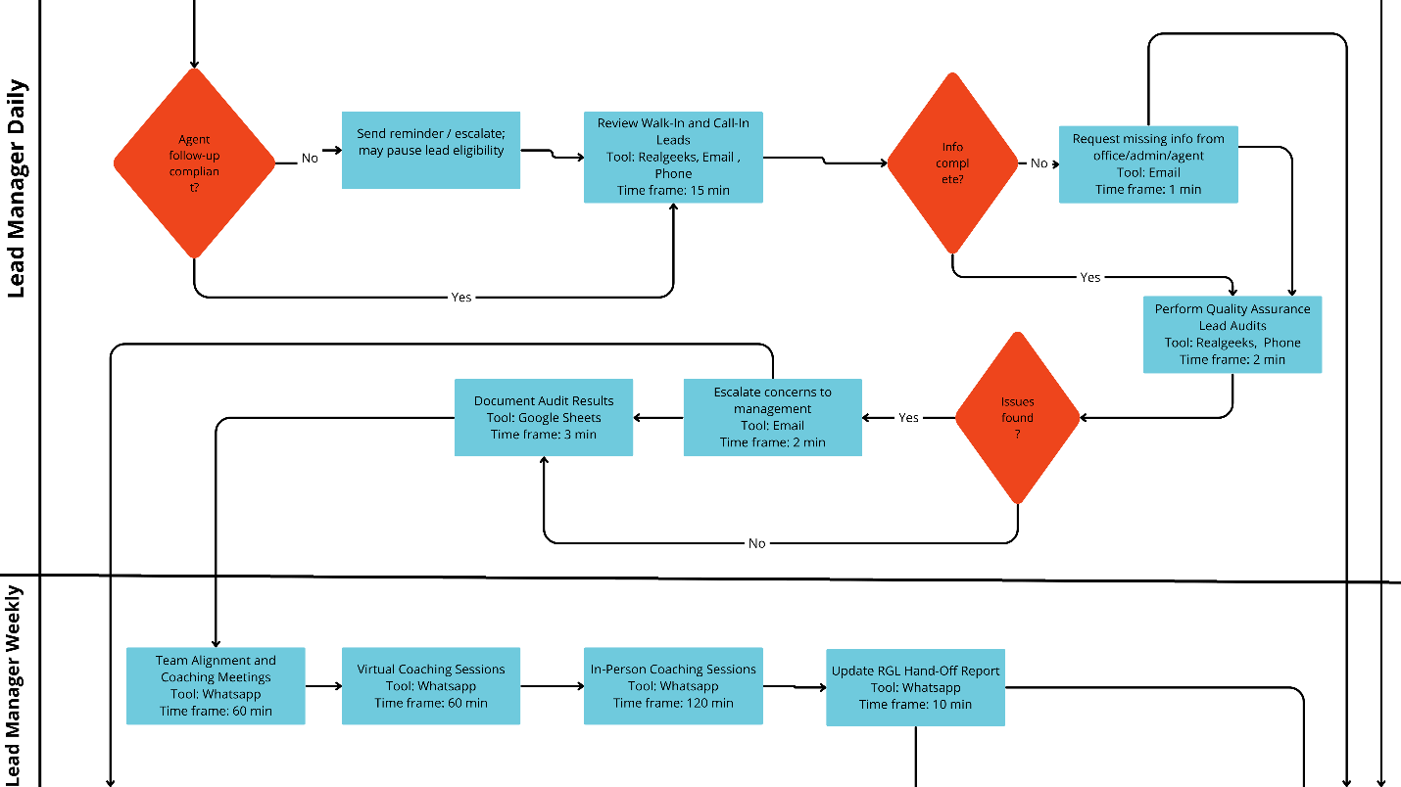

Company Brand | STANDARD OPERATING PROCEDURE  Area: Lead Manager  Prepared: Documentation team  Reviewed: | SOP-1-01  6/2/2026  Version: 1.0  Pg: 12 -13
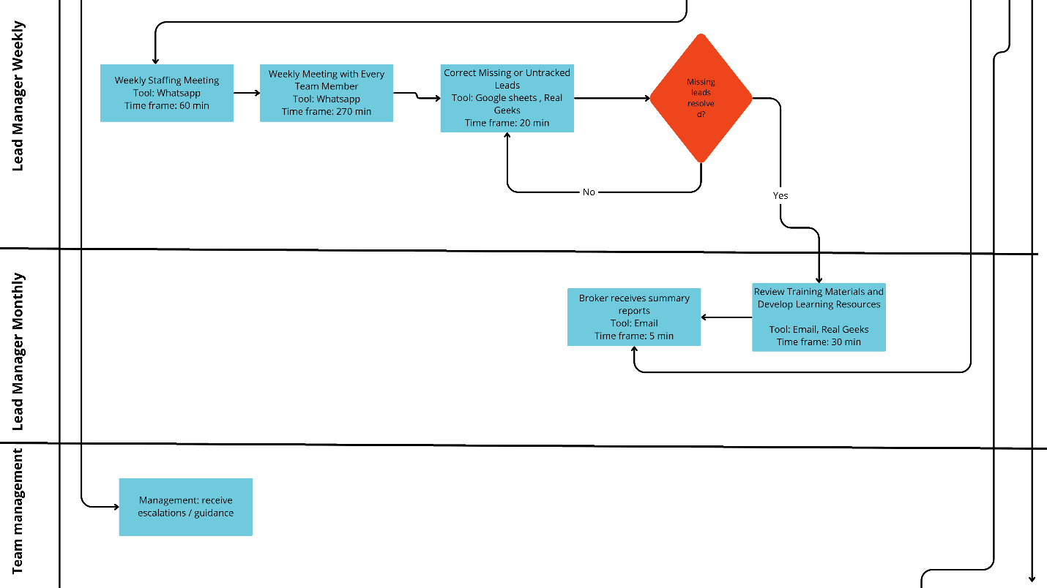

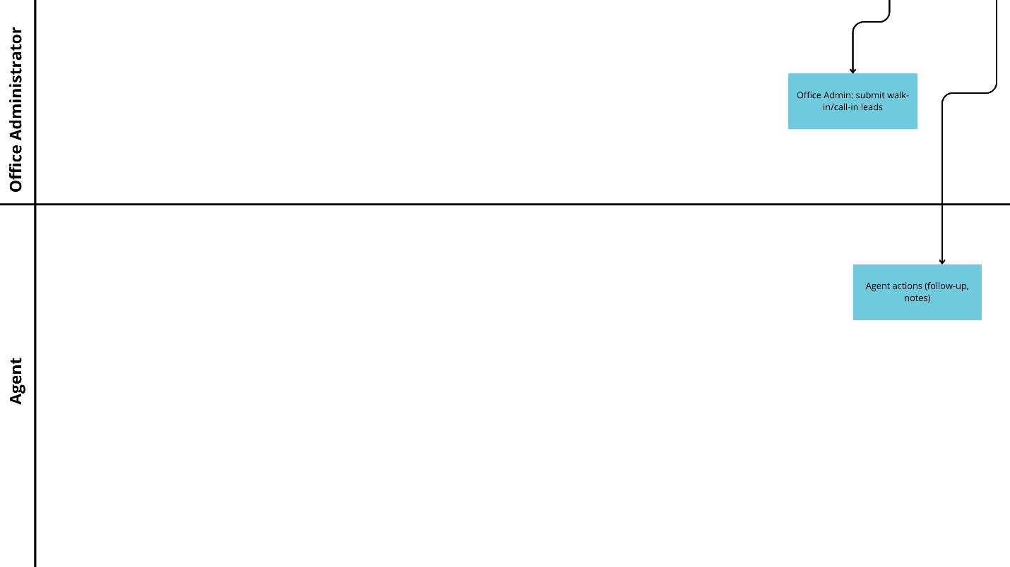

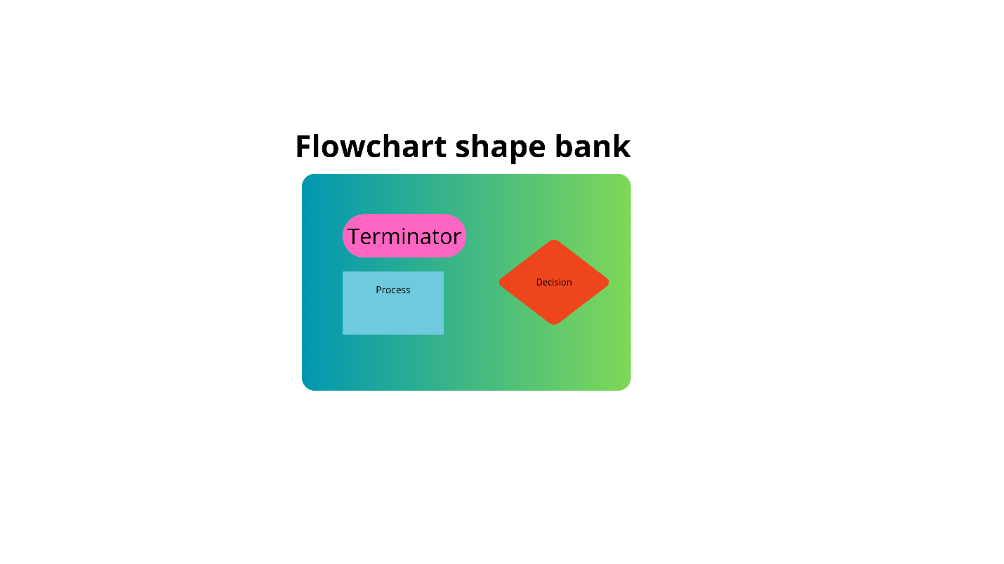

Company Brand | STANDARD OPERATING PROCEDURE  Area: Lead Manager  Prepared: Documentation team  Reviewed: | SOP-1-01  6/2/2026  Version: 1.0  Pg: 13 -13

8 . Version Control
Version | Date Modified | Description | Author
1 | 6/1/2026 | Initial SOP Creation | Documentation team

